Comparative Study on Different Algorithms

# *Raduan Ahamad 191-15-12938*

*Faraz Ahamed 191-15-12948 Sazid Nawas Shovon 191-15-12929 M Shahriar Ishtiaque 191-15-12938*

*Sakib Rokoni 191-15-12961*

Comparative Study on Different Algorithms

### *Algorithms.*

*Introduction*

By using an algorithm whose running time grows more slowly, even with a poor compiler, computer B runs

An algorithm is a finite sequential set of instructions which, if followed, accomplish a particular task or a set of tasks in a finite time. Complexity: The complexity of an algorithm is a function g(n) that gives the upper bound of the number of operations performed by an algorithm when the input size is n. Complexity are divided in two ways. Time complexity is the amount of time the computer requires to execute the algorithm& Space complexity of an algorithm is the amount of memory space the computer requires, completing the execution of the algorithm. In case of algorithm searching is the process to finding to location of the given data elements in the data structure. The different types of searching techniques are Linear search, Binary search. In a modern time where hardware and computing powers are in rapid advancement and invention are often, then why we need algorithms.

For a concrete example **[1]**, let us pit a faster computer (computer A) running insertion sort against a slower computer (computer B) running merge sort. They each must sort an array of 10 million numbers. (Although 10 million numbers might seem like a lot, if the numbers are eight-byte integers, then the input occupies about 80 megabytes, which fits in the memory of even an inexpensive laptop computer many times over.) Suppose that computer A executes 10 billion instructions per second (faster than any single sequential computer at the time of this writing) and computer B executes only 10 million instructions per second, so that computer A is 1000 times faster than computer B in raw computing power. To make the difference even more dramatic, suppose that the world’s craftiest programmer codes insertion sort in machine language for computer A, and the resulting code requires 2n2 instructions to sort n numbers. Suppose further that just an average programmer implements merge sort, using a high-level language with an inefficient compiler, with the resulting code taking 50n lg n instructions. To sort 10 million numbers, computer A takes

**2. (10^7) ² instructions = 20,000 seconds (more than 5.5 hours)**

**10^10 instruction/second**

While computer B takes

## (10^7) lg 10^7 instructions = 1163 1163 seconds (less than 20 minutes)

**10^7 instruction/second**

more than 17 times faster than computer A! The advantage of merge sort is even more pronounced when we sort 100 million numbers: where insertion sort takes more than 23 days, merge sort takes under four hours. In general, as the problem size increases, so does the relative advantage of merge sort.

Linear (Sequential) Search is the basic and simple method of searching: It is a method where the search begins at the end of the list, scans the elements of the list from left to right until the desired record is found. In Binary search the entire sorted list is divided into two parts. We first compare our input item with the mid element of the list & then restrict our attention to only the first or second half of the list depending on whether the input item comes left or right of the mid element. In this way we reduce the length of the list to be searched by half. Less time is taken by binary search to search an element from the sorted list of elements. So, we can conclude that binary search method is more efficient than the linear search. Binary search algorithm is efficient because it is based on divide-and-conquer strategy; which divides the list into two parts and searches one part of the list thereby reducing the search time

## CONCEPT BEHIND SEARCHING Algorithms

CONCEPT BEHIND SEARCHING PROCESS In

linear search, each element of an array is read one by one sequentially and it is compared with the desired element. A search will be unsuccessful if all the elements are read and the desired element is not found. Where Binary search is an extremely efficient algorithm when it is compared to linear search. Binary search technique searches ―data‖ in minimum possible comparisons. Suppose the given array is a sorted one, otherwise first we have to sort the array elements. Then apply the following conditions to search a ―data‖. 1) Find the middle element of the array (i.e., n/ 2 is the middle element if the array or the sub-array contains n elements). 2) Compare the middle element with the data to be searched and then there are following three cases. a) If it is a desired element, then search is successful. b) If it is less than desired data, then search only the first half of the array, i.e., the elements which come to the left side of the middle element. c) If it is greater than the desired data, then search only the second half of the array, i.e., the elements which come to the right side of the middle element. Repeat the same steps until an element are found or exhaust the search area. Again, for searching an ordered array, Interpolation search is used. This method is even more

efficient than binary search, if the elements are uniformly distributed (or sorted) in an array A. Interpolation search is a method of retrieving a desired record by key in an ordered file by using the value of the key and the statistical distribution of the Keys [3]. Consider an array A of n elements and the elements are uniformly distributed (or the elements are arranged in a sorted array). Initially, as in binary search, low is set to 0 and high is set to n – 1. Now we are searching an element key in an array between A[low] and A[high]. The key would be expected to be at mid, which is an approximately position. mid = low + (high – low) × ((key – A[low])/ (A[high] – A[low])). If key is lower than A[mid], reset high to mid–1; else reset low to mid+1. Repeat the process until the key has found or low > high.

## Step 2:

Since (A [3] < data) - i.e., 30 < 45 – reinitialize the variable

LB, UB and mid

|  |  |  |  |  |  |  |
| --- | --- | --- | --- | --- | --- | --- |
| 9 | 10 | 25 | 30 | 40 | 45 | 70 |

0 1 2 3 4 5 6

LB = 3; UB = 6;

mid = (3 + 6)/ 2 = 4

A[mid] = A [4] = 40

### *Step 3:*

Since (A [4] < data) - i.e., 40 < 45 - reinitialize the variable LB, UB and mid

|  |  |  |  |  |  |  |
| --- | --- | --- | --- | --- | --- | --- |
| 9 | 10 | 25 | 30 | 40 | 45 | 70 |

PROCEDURE OF SEARCHING

### *Linear or Sequential Search:* Unsorted array

5 4 21 16 25 3 15

0 1 2 3

LB = 4;

UB = 6;

4 5 6

5 4 21 16 25 3 15

5 4 21 16 25 3 15

5 4 21 16 25 3 15

5 4 21 16 25 3 15

5 4 21 16 25 3 15

5 4 21 16 25 3 15

***Conclusion****:* The element 15 is not present inside that array.

## Sorted array

|  |  |
| --- | --- |
| 4 5 9 11 13 | 10 |
| 4 5 9 11 13 | 10 |
| 4 5 9 11 13 | 10 |
| 4 5 9 11 13 | 10 |
| 4 5 9 11 13 | 10 |

***Conclusion***: The element 10 is not present inside that

### *Binary Search:*

Suppose we have an array of 7 elements

|  |  |  |  |  |  |  |
| --- | --- | --- | --- | --- | --- | --- |
| 9 | 10 | 25 | 30 | 40 | 45 | 70 |

0 1 2 3 4 5 6

Following steps are generated if we binary search a data = 45 from the above array.

### *Step 1:*

|  |  |  |  |  |  |  |
| --- | --- | --- | --- | --- | --- | --- |
| 9 | 10 | 25 | 30 | 40 | 45 | 70 |

0 1 2 3 4 5 6

LB = 0; UB = 6 ;

mid = (0 + 6)/ 2 = 3 A[mid] = A[3] = 30

mid = (4 + 6)/ 2 = 5

A[mid] = A [5] = 45

Step 4:

Since (A [5] == data) - i.e., 45 == 45 - searching is successful.

### *Interpolation Search:*

Consider 7 numbers. 2, 25, 35, 39, 40, 47, 50 Step1:

Suppose we are searching 50 from the array. Here n = 7

Key = 50

low = 0

high = n – 1 = 6

mid = 0+(6–0) × ((50–2)/ (50–2))

= 6 × (48/ 48) = 6 if (key == A[mid])

⇒ key == A [6] ⇒ 50 == 50 ⇒ key is found. Step 2:

Say we are searching 25 from the array Here n = 7

Key = 25

low = 0

high = n – 1 = 6

mid = 0 + (6–0) × ((25–2)/ (50–2))

= 6 × (23/ 48)

= 2.875

Here we consider only the integer part of the midi.e.,

mid = 2 if (key == A[mid]) ⇒ key == A[2]⇒ 25

== 25 ⇒ key is found. Step 3:

Say we are searching 34 from the array Here n = 7

Key = 34

low = 0

high = n – 1 = 6

mid = 0 + (6 – 0) × ((34 – 2)/ (50– 2))

= 6 × (32/ 48)

= 4

if(key < A[mid]) ⇒ key < A[4] ⇒ 34 < 40 so reset high = mid–1⇒ 3

low = 0

high = 3 Since(low < high)

mid = 0+(3–0) × ((34–2)/ (39–2))

= 3 × (32/ 37)

= 2.59

Here we consider only the integer part of the midi.e., mid = 2

if (key < A[mid])

⇒key< A[2] ⇒ 34 < 35 so reset high = mid–1 ⇒ 1

low = 0

high = 1 Since (low < high)

mid = 0+(1–0) × ((34–2)/ (25–2))

= 3 × (32/ 23)

= 1 here (key > A[mid])

⇒key> A[1] ⇒ 34 > 25 so reset low = mid+1

⇒ 2

low = 2

high = 1

Since (low > high)

So― The key is not in the array

### *Longest Common Subsequence*

In this study we will see different solution of longest common subsequence algorithm and difference between their time complexity. The longest common subsequence is an algorithm which finds the common string subsequence between two or more strings. For an example: two strings abcdefghi and

cdgi has the longest common sequence cdgi. A recursive method is given billow of this problem:

Let us consider two arrays A and B.

d

b

|  |  |  |  |
| --- | --- | --- | --- |
| a | b | c | d |

The longest common subsequence is b,d . int Lcs(i,j)

{

if (A[i]== '/0' || B[j] == '/0') return 0;

else if(A[i] == B[j]) return 1=Lcs(i+1,j+1)

else

return max(Lcs(i+1,j), Lcs(i,j+1));

}

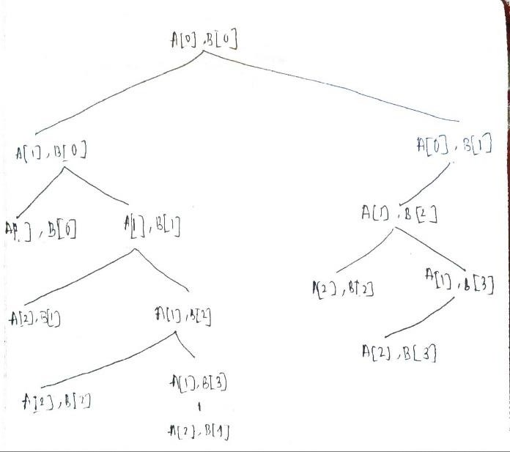

Here we can see same task is happening in the right sub tree. This method is too slow and exponential time complexity. In worse case when there is no matching common subsequence between A and B time complexity of the algorithm is: 2m*n

We can do it with linear time with memorization and other dynamic programing methods.

### *Longest common subsequence using memorization* (Top Down)

int lcs (string X, string Y, int m, int n, int dp[][maximum])

{

// base case

if (m == 0 || n == 0) return 0;

// if the same state has already been

// computed

if (dp[m - 1][n - 1] != -1) return dp[m - 1][n - 1];

// if equal, then we store the value of the

// function call

if (X[m - 1] == Y[n - 1]) {

// store it in arr to avoid further repetitive

// work in future function calls

dp[m - 1][n - 1] = 1 + lcs(X, Y, m - 1, n - 1, dp);

return dp[m - 1][n - 1];

}

else {

// store it in arr to avoid further repetitive

// work in future function calls

dp[m - 1][n - 1] = max(lcs(X, Y, m, n - 1, dp),

lcs(X, Y, m - 1, n, dp));

return dp[m - 1][n - 1];

}

}

Use a 2-D array to store the computed lcs(m, n) value at arr[m-1][n-1] because the string index starts from 0. Whenever the function with an equivalent argument m and n are called again, don't perform any longer recursive call and return arr[m-1][n-1] because the previous computation of the lcs(m, n) has already been stored in arr[m-1][n-1], hence reducing the recursive calls that happen more than once.

char lcs[index + 1]; lc[index] = '\0';

int i = m, j = n;

while (i > 0 && j > 0) {

if (S1[i - 1] == S2[j - 1]) {

lcs[index - 1] = S1[i - 1]; i--;

j--;

index--;

}

else if (LCS_table[i - 1][j] > LCS_table[i][j - 1]) i--;

else j--;

}

// Printing the sub sequences

cout << "S1 : " << S1 << "\nS2 : " << S2 << "\nLCS:

" << lcsAlgo << "\n";

}

**Time Complexity:** O(M*N), where M and N is length of the first and second string respectively.

**Auxiliary Space:** (M*N)

### *LCS with tabulation method (Bottom Up)*

First, we create a table of dimension n+1*m+1 where n and m are the lengths of

strings respectively. The first row and the

|  |  |  |
| --- | --- | --- |
| X | and | Y |

first column are filled with 0.

If the character of previous rows and column are

matching then fill the slot with previous diagonal slots number and adding 1 with it.

Else fill the slot with the maximum number of previous slot of rows and column.

After filling the table, the last number of last row and last column is the length of longest common subsequence. And if we want to find the sequence, we need to backtrack the table.

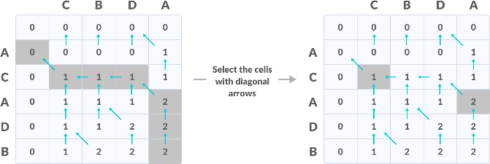

Here the longest common subsequence is CA. void lcs(char *S1, char *S2, int m, int n) {

The time complexity of this method is O(m*N).m stands for rows and n stands of column. Because we need to backtrack m*n element in the worst case.

int LCS_table[m + 1][n + 1];

// Building the mtrix in bottom-up way for (int i = 0; i <= m; i++) {

for (int j = 0; j <= n; j++) { if (i == 0 || j == 0) LCS_table[i][j] = 0;

else if (S1[i - 1] == S2[j - 1])

LCS_table[i][j] = LCS_table[i - 1][j - 1] + 1; else

LCS_table[i][j] = max (LCS_table[i - 1][j], LCS_table[i][j - 1]);

}

}

int index = LCS_table[m][n];